P.O. Box 127
West Decatur, PA 16878
Email: info@nittanybeaglerescue.org

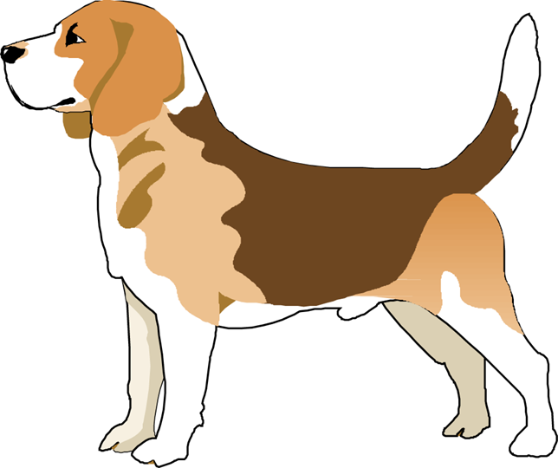

Nittany
Beagle
Rescue

ADOPTION & FOSTER HOME APPLICATION
Name:
Home Phone:
Work Phone:
Cell Phone:
Email Address:

Does anyone in your
house have allergies?

What are the
allergies?
Address:

Occupation:

Why did you choose a Beagle?

Have you ever owned a Beagle before?

Will this Beagle be mainly A housedog? An outdoor dog?

How many adults live at home?

Do they all work?

What is the longest time the
Beagle will be left alone?

Where will the Beagle
be left when alone?

How many children at home?
Names:
Ages:

Is anyone in your home afraid of dogs?

Do you own your house?

How long have you lived there?

Do you rent?

Does your lease allow pets?
Landlord’s name & phone number?

Is your yard fenced?

How tall is the fence?
What material is the fence? (chainlink, wood?)
When the application is approved, are you interested in?:

Specific Beagle? Male? Female? Tricolor ? No Preference?

13” 15” Adult? Puppy? Blonde? Maximum Age?
Are you prepared financially to provide proper medical and personal care for a Beagle at this time? (About $1,200.00 per year?)
Current Pets:

Names:

1.)

2.)

3.)

4.)

Vet. name & phone number?
Type

Age
Sex (altered?)
Up to date on Shots, etc.?
Previous Pets:
Names:

Type
What happened to them?
How long ago?
Vet. name & phone number?

I give my permission for the veterinarians above to supply information to Nittany Beagle Rescue with regard to my pets.

Signature:_______________________________
Personal References: (no relatives)
Name:

Phone
Name:

Phone:
I confirm that the above information is correct and I give my permission to contact the veterinarian, landlord, and references that are listed.

DATE:__________________ SIGNATURE:____________________________

Please allow up to two weeks from the date you return the application for us to process it. If you are requesting a specific sex/age it may take longer to match your request with an appropriate Beagle. Adoption fee is $250.

